Brown Clee C.E. Primary School
Station Rd, Ditton Priors, WV16 6SS
01746 712652
admin@brownclee.shropshire.sch.uk

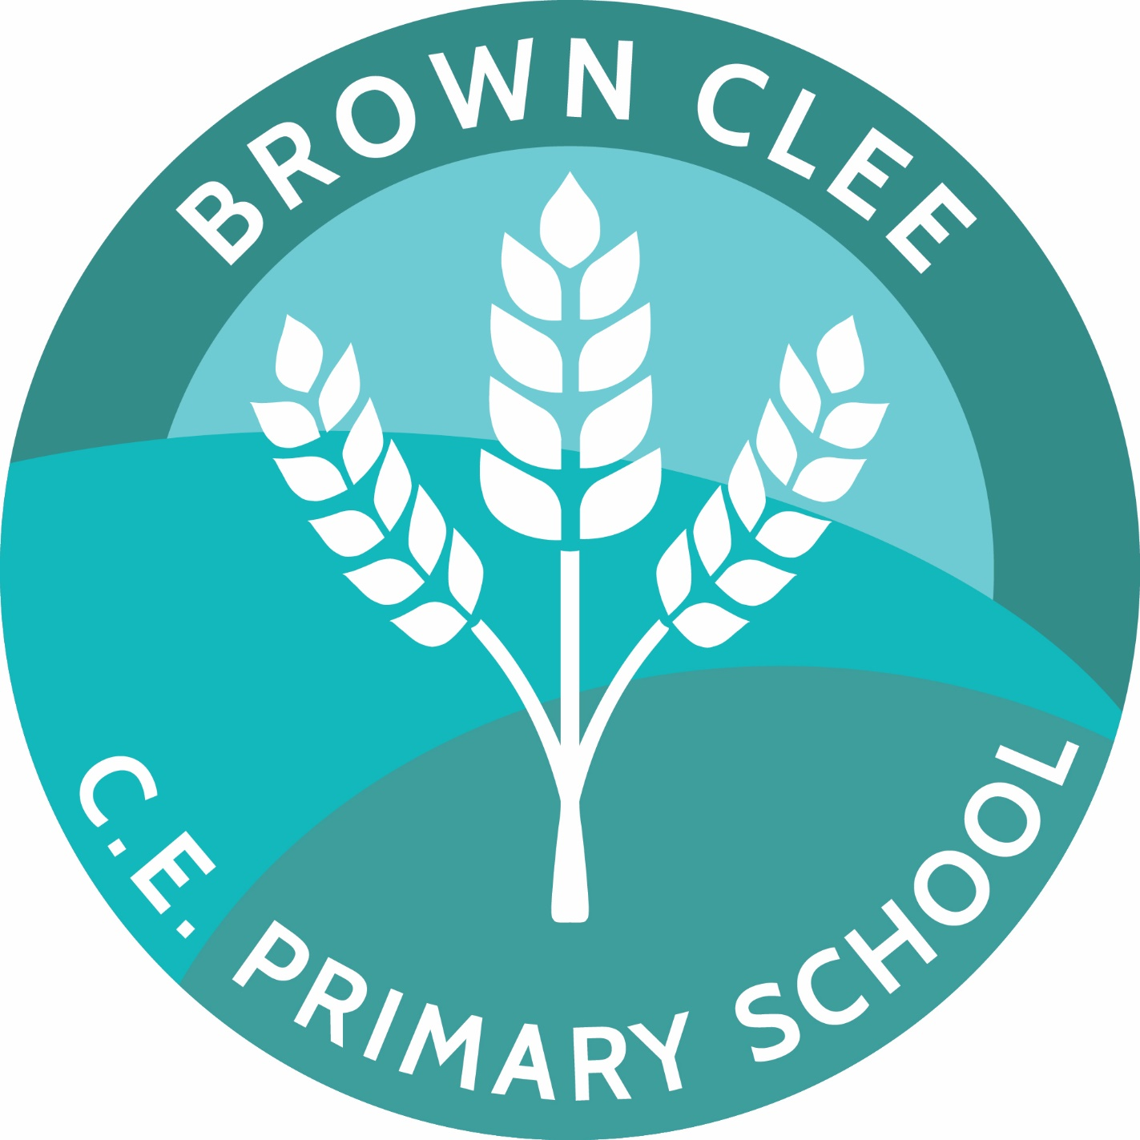

Vacancy: Class Teacher: Mixed-age EYFS/Year 1

Post: 0.2 FTE (Friday) Teacher from 17th April 2023 (Sooner if possible)
Salary: MPR
Status: (Fixed Term initially with possibility of extension from September 2023)

We are seeking a teacher who is creative, enthusiastic and ambitious and can demonstrate consistent, excellent teaching. A good knowledge of the EYFS framework will be essential alongside a secure understanding of the KS1 framework. Previous experience in a mixed age class would be preferrable.

This is an exciting opportunity for an experienced, committed and able professional to contribute to the development of our thriving School.

You will:
- Have high aspirations for and high expectations of children.
- Be an excellent and enthusiastic classroom practitioner.
- Be self-motivated and committed to providing children with a stimulating, creative curriculum and learning environment.
- Have a positive and adaptable attitude, and be willing to participate fully in school life.
- Be a strong team member who can support and motivate others.
- Share the schools aims and Christian values.

We can offer:
- A welcoming and caring school with happy, motivated and well-behaved children.
- Attractive, well-resourced buildings and grounds in a stunning rural location.
- The support of hardworking and dedicated staff team.
- A supportive headteacher and governing body who care about staff well-being and professional development.

Visits to the school are welcomed and encouraged. Further details can be obtained by contacting Mrs Mandy Lloyd (our wonderful Administrator) email: admin@brownclee.shropshire.sch.uk or (01746) 712652

Completed application should be returned to the school either by email or post.

Closing date: Tuesday 31st January (midday) 2023
Interview date: 14th February 2023

Brown Clee C.E. Primary School is committed to safeguarding and promoting the welfare of children and expects all staff, and volunteers, to share the same commitment. The successful applicants will be subject to an enhanced DBS check.

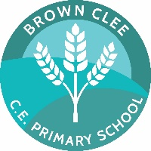
Brown Clee C.E. Primary School
Station Rd, Ditton Priors, WV16 6SS
01746 712652
admin@brownclee.shropshire.sch.uk

Person Specification – Class Teacher: EYFS / Year 1

The successful candidate will demonstrate:

- High expectations for their own teaching practice.
- Personal enthusiasm, energy and purpose.
- High expectations for pupil achievement, progress and behaviour.
- A willingness to listen to pupils and a commitment to their pastoral care.
- A willingness to follow the school’s positive behaviour strategy.
- An ability to communicate effectively.
- An ability to work effectively as part of a team, in partnership with parents, carers, teachers and other professionals.
- A good understanding of the teaching, learning and assessment process.
- A thorough understanding of the Primary Curriculum.
- A willingness to support the church ethos of the school
- The commitment and capacity to work within a small school
- A commitment to CPD, school priorities and whole school improvement
- A willingness to take on the leadership of an agreed curriculum area
- A commitment to safeguarding

Brown Clee C.E. Primary School
Station Rd, Ditton Priors, WV16 6SS
01746 712652
admin@brownclee.shropshire.sch.uk

Job Description – Class Teacher: EYFS / Year 1

The governing body is committed to safeguarding and promoting the welfare of children and young people and requires all staff and volunteers to demonstrate this commitment in every aspect of their work.

In accordance with the Teachers’ Standards, the school’s policies and under the direction of the Headteacher:

Specific Responsibilities:

To have responsibility for the education and welfare of pupils in a mixed-age Reception / Year 1 Class on Fridays.

Teaching:

Having regard to the curriculum for the school, and with a view to promoting the development of the abilities and
aptitudes of the pupils in any class or group assigned to you:

- Plan and prepare courses and lessons;
- Have a full and up to date knowledge of the new National Curriculum;
- Teach all pupils according to their educational needs and with high expectations for all.
- Set and mark work to be carried out by the pupil in school and elsewhere;
- Assess, record and report on the development, progress and attainment of pupils;

Other Activities:

- Promote the general progress and well-being of individual pupils and of any class or group of pupils
assigned to you;
- Provide guidance and advice to pupils on educational and social matters and, where appropriate, on their further education and future careers, include information about sources of more expert advice on specific questions; make relevant records and reports;
- Make records of and reports on the personal and social needs of pupils;
- Communicate and consult with the parents of pupils;
- Communicate and co-operate with persons or bodies outside the school; and participate in meetings arranged for any of the purposes described above;

Assessments and reports:

- Provide or contribute to assessments, reports and references relating to individual pupils and groups of pupils;

Appraisal or review of performance

- Participate in arrangements made in accordance with the 2002 Regulations or the 2006 Regulations for
the appraisal or review of your performance and that of other teachers;

Review, induction, further train and development

- Review from time to time your methods of teaching and programmes of work;
- Participate in arrangements for your further training and professional development as a teacher
including undertaking training and professional development which aims to meet needs identified in planning and review statements.

Working with others:

- Communicate effectively with learners, colleagues and parents;
- Relate positively to pupils providing a calm, caring approach;
- Develop good working relationships with other staff;
- Identify opportunities for working with colleagues, managing their work where appropriate and sharing the development of effective practice with them;

Learning Environment:

- Be able to plan and develop a stimulating, purposeful and safe learning environment having high regard for good classroom organisation, display and tidiness.

Terms and Conditions

The post is subject to the following terms and conditions :

- Those set out in the School Teachers’ Pay and Conditions Document 2006.

- The other terms and conditions set out in the various national collective agreements in force from time to time.

- The Local Authorities Rules and Conditions including any local agreement entered into with recognised trade unions.

- The school’s Instrument and Articles of Government as appropriate.

- The other conditions set out in this job description and any others set out in a letter of appointment.

Applications and Selection

Completed application forms should be accompanied by a letter which includes the applicant’s skills and experience in relation to the job description and person specification above. The letter should be no more than two sides of A4.

Separate CV’s are not required.

Interviews will be on the 14th February , with a lesson observation to be held in Brown Clee School during the week beginning 6th February.

